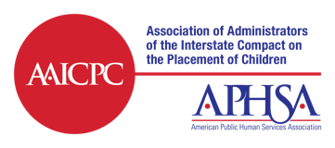
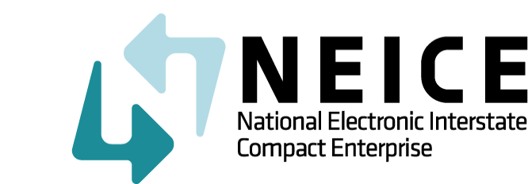

NEICE ICPC Coordinator Training
February 9, 2021
1:00-2:30 PM (ET)

Agenda:

- Welcome to NEICE 2.0
- Review of 2.0 Key Features
- Case Creation Wizard Demonstration
  - Using the Sending Case Wizard to Create a Case
- Case Management Demonstration
  - Process a Case Created by the Local Agency in your State
  - Processing a Case Received from another State
- Q&A: Answer any questions you have based on:
  - Your experience using NEICE
  - Your completion of E-Learning
  - Your review of the Job Aids and Mini-Guide
- Your practice in Test or UAT recommendation

